The majority of the progress of the mirror project has been made on refining the various components of the experimental setup. We have taken a very close look at the different pieces involved and performed a number of tests to identify potential problems with the design.

Snap down experiments were performed to verify that our predictions matched correctly to real world tests. In these tests we would simply increase the voltage or number of activated area segments until snap down occurred. A laser shined on the mirror which reflected onto a quad cell measurement device. We took a sharp jump in the reading from this quad cell measurement to mean snap down. This was typically accompanied by a distinct hissing sound which is most likely the sound of the mirror material burning.

One interesting observation of these tests is that all of the mirrors shared a similar burn hole after being taken to snap down. This hole was in the exact same location for each of the mirrors. Even more interesting is that this hole was not in the center of the concentric area segments, as would be expected. It was also seen that small bumps would appear on the surface of the mirrors. These bumps also appeared to be in the same position on each of the mirrors. This made it unlikely that the bumps were caused by random dust or dirt that might be trapped between the mirror and the area segments.

On close inspection, we found that the hole and the bumps on each of the mirrors lined up with the vias on the activation board. These vias connect the traces on the back of the activation board to the concentric area segments on the front of the board. Although extra care was taken during the fabrication process in an attempt to keep the area segments flat, the vias still rose above the surface of the activation areas. When dealing with gap sizes as small as 63.5µm, this poses a problem.

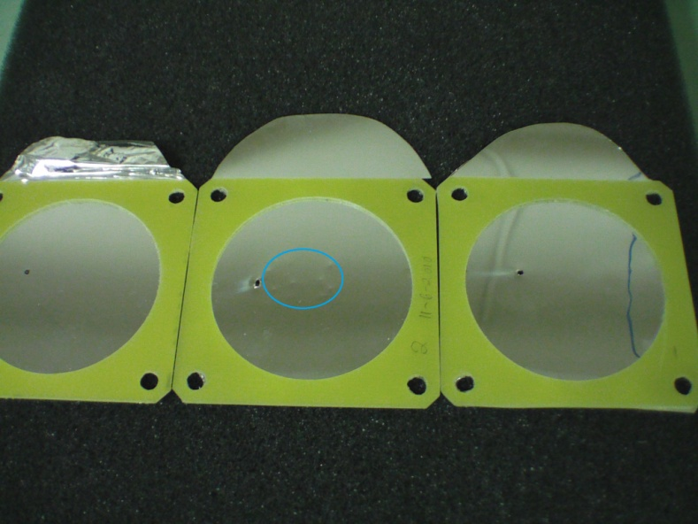

Figure 3 different mirrors showing the same burn hole. You can also see the bumps on the middle mirror (inside the blue circle)

Two different variations on the current fabrication process of the activation boards were conceived. The first idea was that when drilling the holes into the board on the CNC milling machine that we would not let the drill bit go all the way through the PCB board. We then tediously lowered the height of the drill bit using the fine tuning controls and ran it again over the same drill pattern. Ideally, we would have made it to just beneath the copper material of the area segments on the opposite side and then attempted to solder in a via. This would result in a flat surface of the area segment while still being electrically connected to the traces on the back of the board. The problem, however, was that as we got close to the copper on the opposite site of the board, the drill bit began pushing the remaining PCB material through the other side. This resulted in a lumpy surface that was not any better than what we had before.

In the next idea we thought to drill all the way through as we had before. This time though we were going to do a copper rub on the portion of the board where we wanted the area segments. This removes all the copper in that spot and leaves a plain PCB surface to work with. We then took an adhesive copper laminate material and fit a piece of it over the portion of the PCB that we performed the copper rub on. This resulted in holes that went all the way through the PCB material and ended just beneath the copper on the other side. We then continued the milling process as normal to get the concentric area segments on the board which we had hoped would result in a smooth surface. A few problems arose with this. First, the mill bit caused the laminate to bulge upwards around the edges where it was cut. Next, the inner pad was of very small size and did not have enough adhesive to securely hold itself to the board. The last problem is that we found it very difficult to solder a via in this manner.

At this point we decided that we didn’t have the tools, or at least the time, to get the precision that we needed for these experiments. We then looked into options for outsourcing this fabrication. Many different companies were looked at to see what was feasible and who had the best prices. AdvancedPCB out of California was the company that we selected. There were some modifications that had to be made to our PCB design files in order for them to be manufactured on the less expensive CNC milling machines. The biggest change was the size of the area segments. Due to fabrication restrictions, our smallest area segment would not allow for the placement of its via. This meant that we had to increase the size of our area segments which in turn increased the overall size of our board. This in turn increased the size of our mirror needed and necessitated a redesign of the mirror itself.

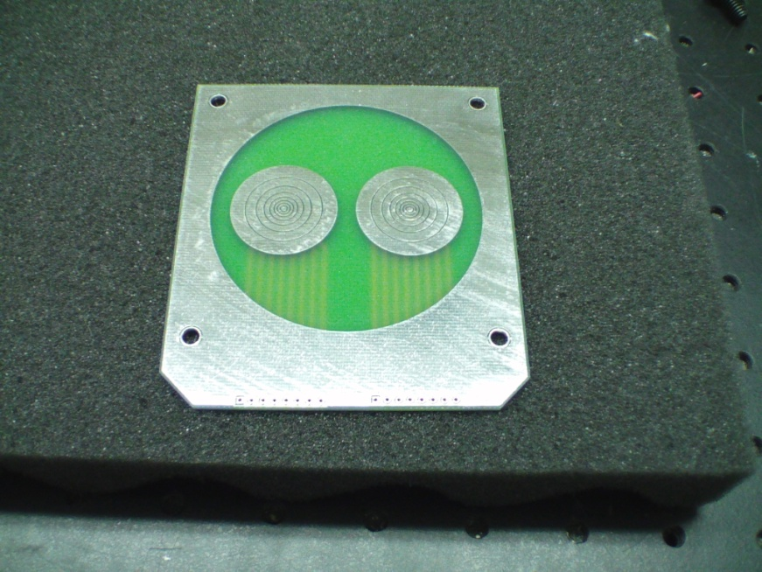

Figure Front side of the new activation board

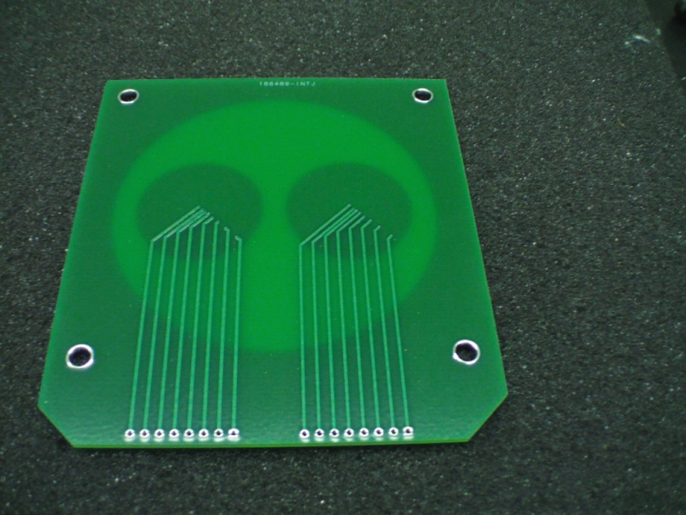

Figure Back side of the new activation board

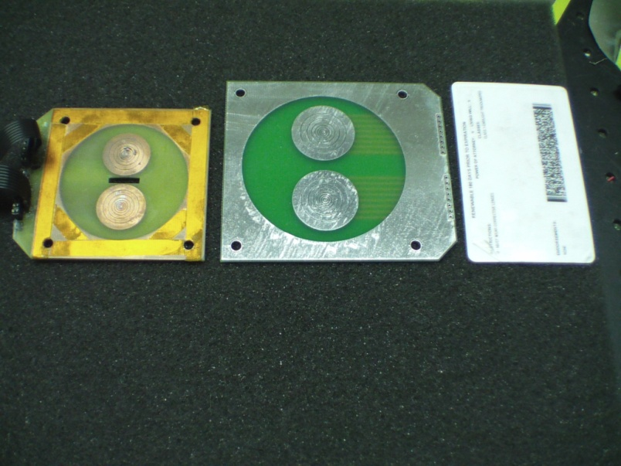

Figure Comparison of old activation board to the new one. On the left is the old board, the middle is the new board, and on the right is a standard ID card for size reference

These increases in size for the mirror and activation board also brought about the need for a new mounting structure which could accommodate them. The optical mount from the previous design was kept since it allows for fine adjustments to the mirror’s orientation. In the previous design, a copper rubbed PCB board was taped to the optical mount. The PCB board had specific holes cut out which allowed us to bolt the activation board and mirror to it. The material appeared to be flimsy though and its ability to provide accurate results was questionable. In the new design, a 1-inch thick piece of acrylic is used for the main mounting surface. This material was selected due to it being readily available, fairly easy to machine, and also because it will provide a solid surface for the mirror and activation board. A separate piece of acrylic was cut which fits into the backside of the optical mount through the circular hole. The main acrylic square was then attached to this smaller piece using long bolts. The head of these bolts are recessed into the main square so that the activation board can lay flatly over them. Four more bolts were then installed which protrude through the front of the main square. The heads of these bolts are recessed as well to allow the main square to lie flatly on the optical mount. These bolts provide a way to consistently place the activation board and mirror onto the mounting structure. They were intentionally left extra long to provide room for any additional pieces that we might wish to implement in the future. The figures below show the step by step process of putting the new mounting system together.

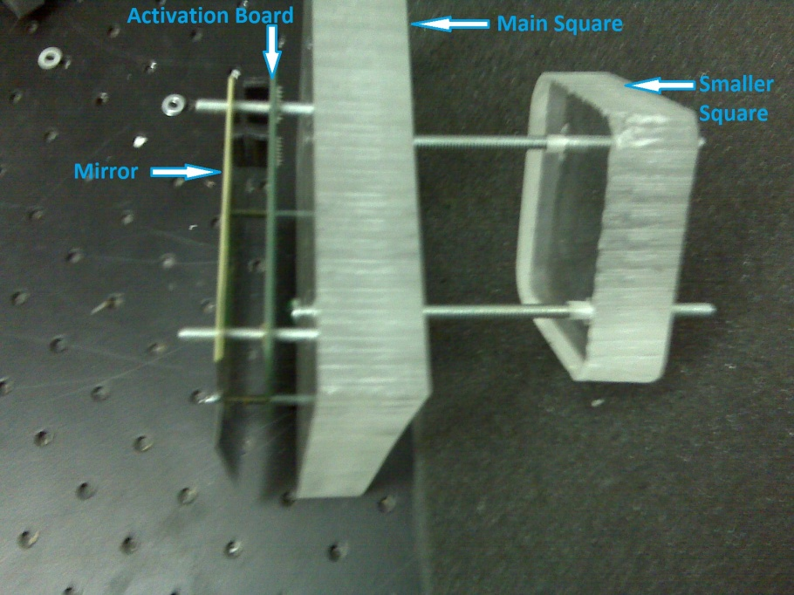

Figure 5 New mounting system. As shown, it is not on the optical mount. The pieces are also separated to give a better idea of how everything fits together.

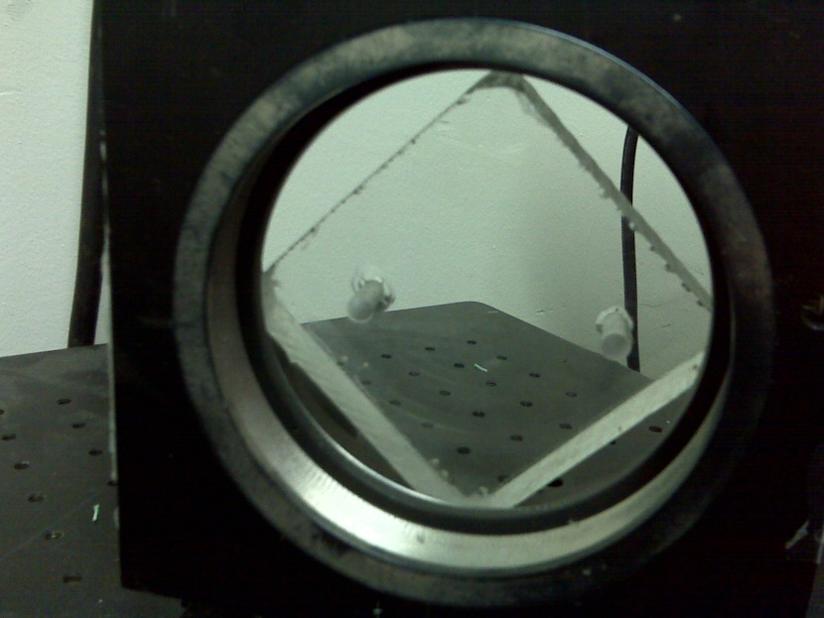

Figure Smaller square inserted into the back of mirror mount

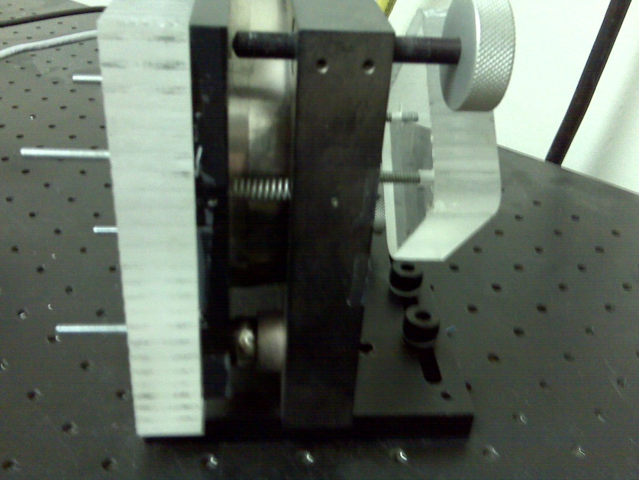

Figure Side view of the main square being attached to the smaller square with the optical mount between them

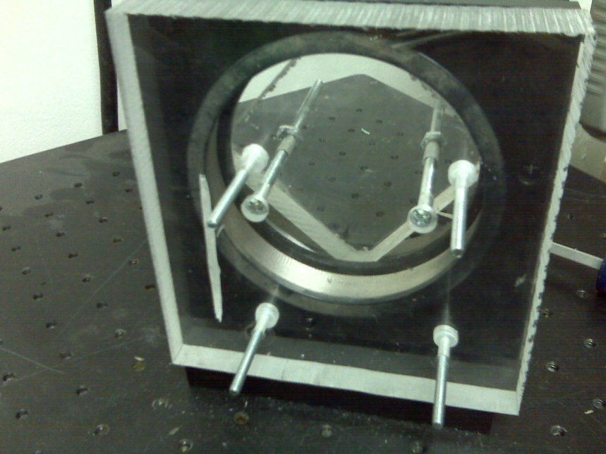

Figure Front view of the system with the main square attached to the smaller square. You can also see the recessed heads of the two bolts that attach the squares together, as well as the four bolts that protrude through the front. The groove on left side of the main square provides clearance for the wire-to-board connectors that are on the activation board.

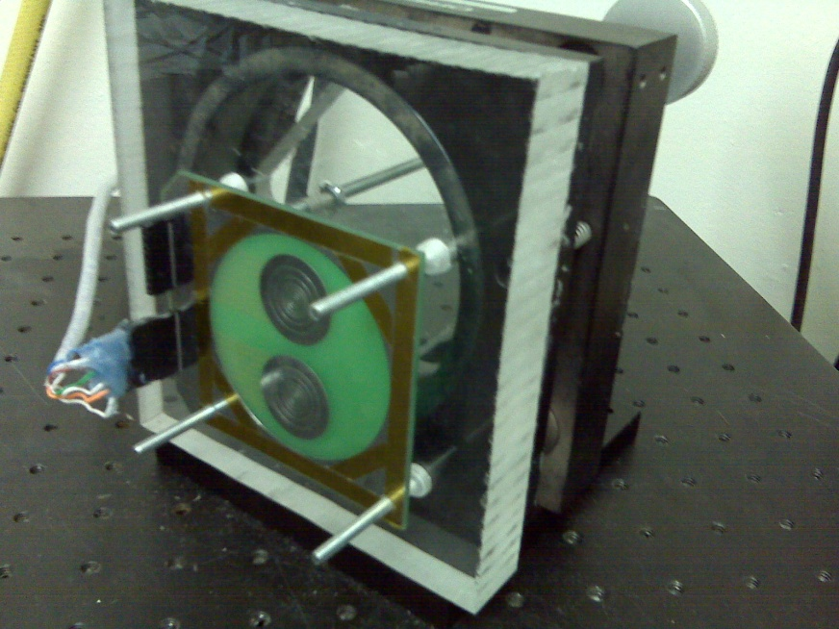

Figure New setup with activation board in place

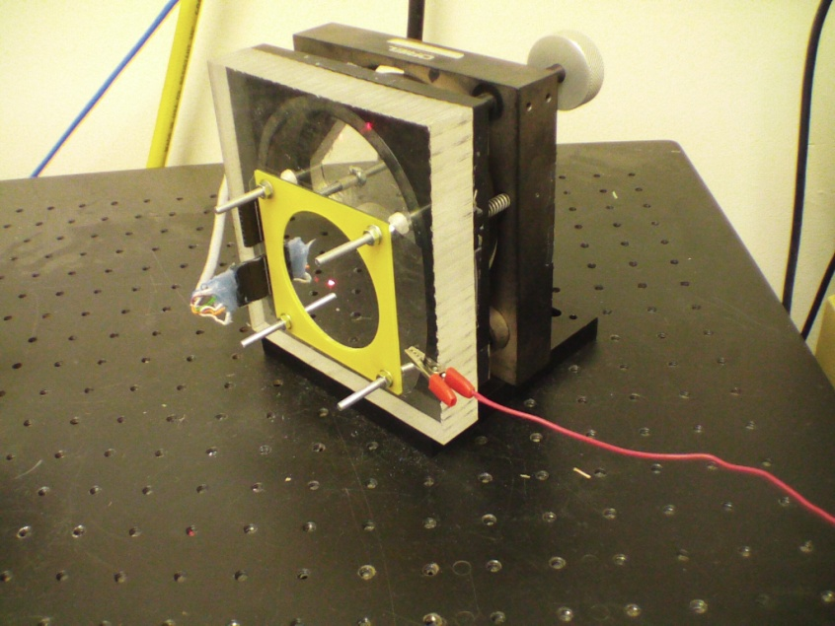

Figure New setup with mirror in place. Ground is hooked up (right) and the laser is on

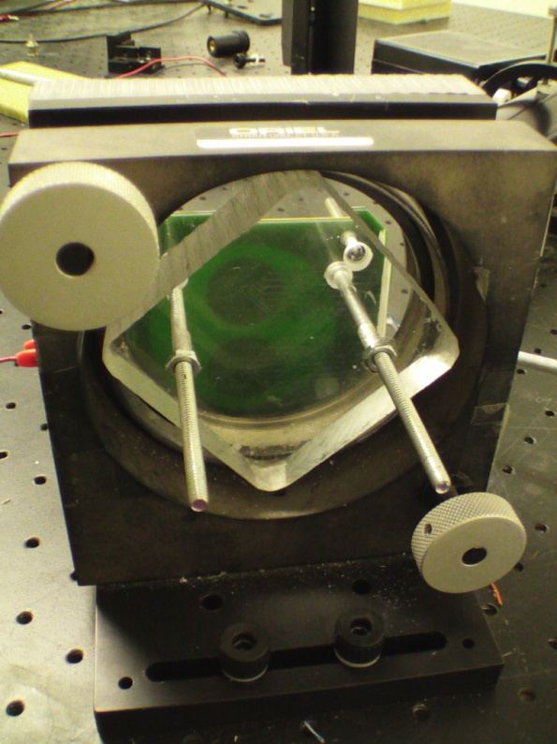

Figure Back side of the new setup with the activation board and mirror in place

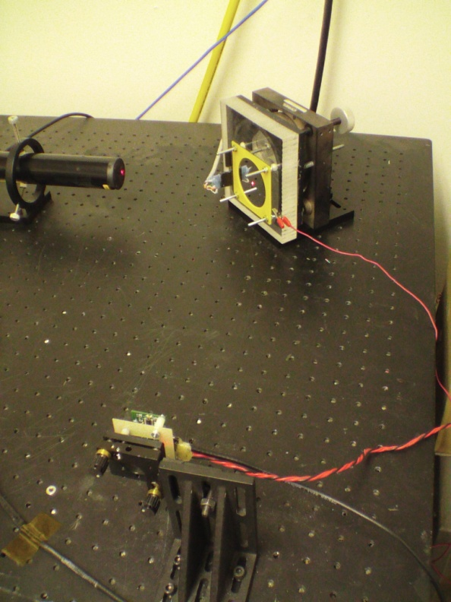

Figure Overview of the whole laser/mirror/quad cell setup

Further snap down tests have been performed using the new activation board. In none of the tests have we seen a recurring burn hole or bumps. Although the area segments of the new board do not appear to be perfectly flat, they do not appear to have any sharp points that protrude upwards. We feel that this should be a significant improvement and will make a big difference when we attempt to achieve large gap deflections.

Another potential problem in the system that was identified was in relation to the boundary condition of the mirror. As describe in previous reports, the mirror is made by adhering a tensioned mirror membrane to a PCB square with a circular hole cut in the middle. This is what we used to create a circular boundary condition. After more thought, it was decided that this might not be enough since the mirror is mounted by essentially clamping the four corners. There is nothing to actually clamp and tightly hold the circular boundary. A new piece was created in an attempt to achieve a better boundary condition. We started by milling the same PCB square which is used for the mirror. We then mill out a ring that has the same radius as the hole of the PCB square. This is then glued around the hole of the PCB square. This can now be placed over the mirror in the mounting system and tightened down. This should provide a better boundary condition.

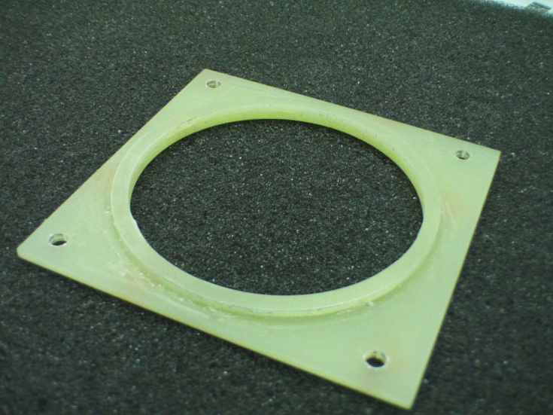

Figure Piece developed to create a better boundary condition for the mirror

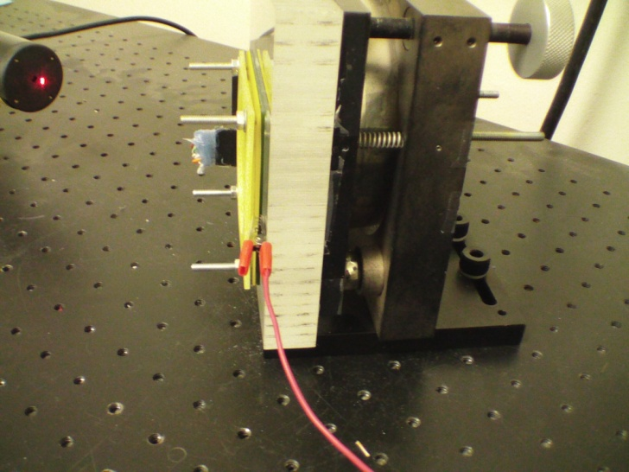

Figure System with the boundary piece in place

Experiments were performed to test the system with the boundary piece and without. We built up a program to turn on all of the area segments for one of the concentric circle groupings and then record the quad cell measurements. We saw that there was a significant difference between the tests using the boundary piece and those without. The significance of these results is not yet understood, but they test results more than warrant a closer look at our setup in respect to the boundary conditions.

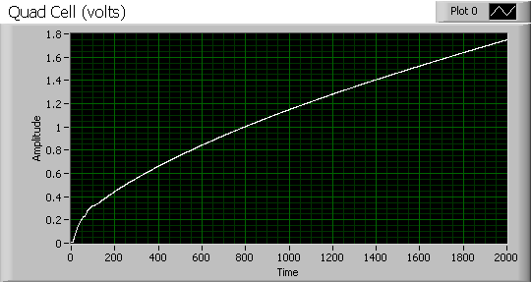

Figure Quad cell measurements, system WITHOUT boundary

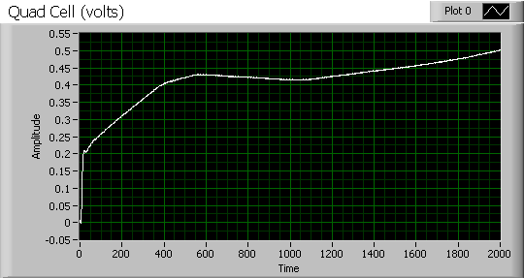

Figure Quad cell measurements, system WITH boundary